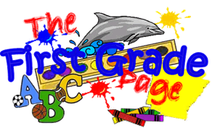

January 17, 2020

We had another wonderful week in school. Please mark your calendars: Our classroom is planning next Tuesday’s Mass (1/21) as well as the following one (1/28). That means that students from our class read at the altar, bring up the gifts, and plan the hymns that are sung. If you can join us in the church for those Masses (at 8:15), we’d love to see you!

This Week in First Grade…

Language Arts- This week we learned how to draw conclusions from things we’ve read. We also learned the long o, u, and e sounds. In grammar we focused on the verbs is and are.

Math- We worked on subtracting numbers through 20. We also did some “mixed practice” where the students had adding and subtraction problems mixed together and they had to “look for the sign” to see what they were supposed to do.

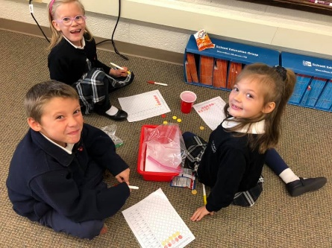

UPCOMING EVENTS:
Our Upcoming Week…

Monday No School, MLK Day

Wednesday Star Renaissance Math Test

Friday All School Mass

Looking Ahead…

Jan. 26 Open House 11-1:30

Jan. 26-1 Catholic Schools Week

Feb. 1 St. Paul Auction

Save the dates!

Next Week’s Homework:
Monday- No School
Tuesday- A Loving Leader
Wednesday-Blast Off!
Thursday- Practice Spelling Test
Friday- No Homework

(Enjoy the Weekend!)

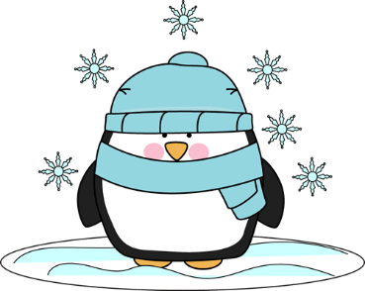

Here’s What We’re Doing Next Week!

Language Arts: compare/contrast, 3-letter blends, contractions

Math: problem solving, Chapter 6 Test

Religion: responding to and trusting in God

Writing: informational writing

Science: land and water habitats

Social Studies: Martin Luther King, mapping skills

Weekly Words
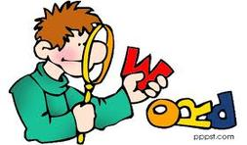
Just a reminder that our spelling words are also our sight words. Our goal is for the first graders to not only be able to SPELL these words, but also to read them. When practicing throughout the week, please help them with both concepts. They are learning many new words each week, so practice will help them feel more confident when reading.

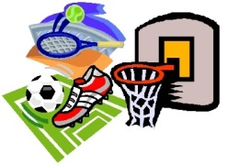
Weekly Specials:
Monday-Gym
Tuesday-Art
Wednesday-Music
Thursday-Library & Technology
Friday-Spanish
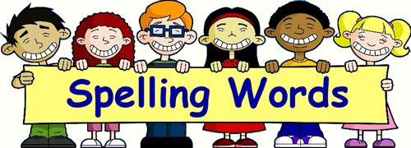
Next Week’s
Spelling/Sight Words
strike
string
splash
split
scrub
scrap
any
boy
by
does
friends
girl
water

Next Week’s Vocab Words:
culture
custom
language
similar
skill

