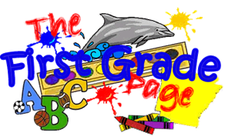

January 24, 2020

We had a terrific week in first grade! On Tuesday we celebrated the Mass we planned as a class. I was so proud of the students who brought up the gifts, read, or helped plan the hymns. We are planning next Tuesday’s Mass as well. If you have an opportunity to join us at 8:15, that would be great!

This Week in First Grade…

Language Arts- This week we learned to compare and contrast different things from our texts. We also focused on three letter blends. In grammar we worked with contractions.

Math- We completed our chapter on addition and subtraction. Many students understood the concepts but struggled with the math facts. Please continue practicing flash cards with your children to help them gain confidence in this area.

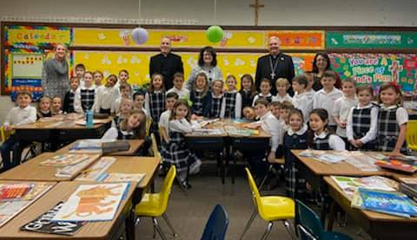

UPCOMING EVENTS:
Our Upcoming Week…
Sunday Wear your uniform to Mass.
Open House 11-1:30
Monday Jeans Day $1 (red white blue theme)
Tuesday Crazy sock & tennis shoe day.
Thursday Hat Day
Friday All School Mass
Spirit wear w/ jeans
Saturday St. Paul Auction

Looking Ahead…

Feb. 17-21 No School – Winter Break

Save the dates!

Next Week’s Homework:
Monday- Read & Do
Tuesday- Print the Word
Wednesday-Numbers, Yum!
Thursday- Practice Spelling Test
Friday- No Homework

(Enjoy the Weekend!)

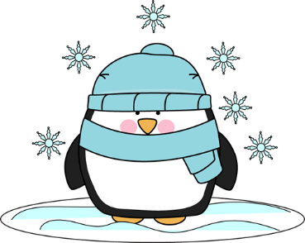

Here’s What We’re Doing Next Week!

Language Arts: make & confirm predictions, was/were verbs, long a (ai, ay)

Math: geometry,

Religion: responding to and trusting in God

Writing: opinion writing

Science: herbivores, carnivores, and omnivores and animals who use camouflage

Social Studies: Martin Luther King, mapping skills

A few things…

- Wear your St. Paul uniform to any weekend Mass this Sunday to show school pride. Free dress pass to all students who participate!

- Please continue to practice sight words and flash cards daily to help your child become confident with both.

- Please remember during cold and flu season to keep your child home when s/he is ill. We appreciate the “24 hour rule” when it comes to vomiting and fever.

Weekly Specials:
Monday-Gym
Tuesday-Art
Wednesday-Music
Thursday-Library & Technology
Friday-Spanish
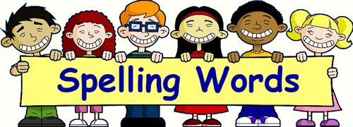
Next Week’s
Spelling/Sight Words
mail
chain
play
rain
way
day
across
once
saw
carry
eight
upon
walked

Next Week’s Vocab Words:
encourage
relationship
friendship
rely

