February 14, 2020

What an exciting week to be a 1st Grader!
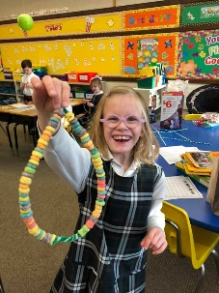
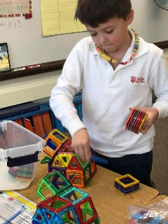
We celebrated the 100th day of school and Valentine’s Day in one week. Thank you to all the parents who helped make our classroom party a success. Thank you to our room moms, Mrs. Bufalino and Mrs. Hanawalt, for organizing such a fun party.

This Week in First Grade…

Language Arts- This week we focused on retelling. We also worked on different ways of spelling the long o sound (o, oa, ow). In grammar we worked with the verbs do and go.

Math- We completed our unit on geometry and took our test. The students enjoyed this unit a great deal.

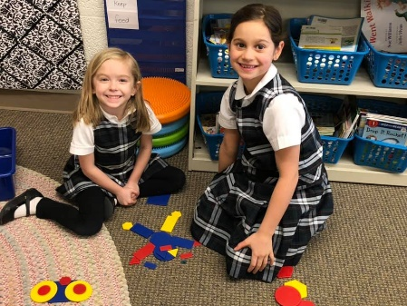
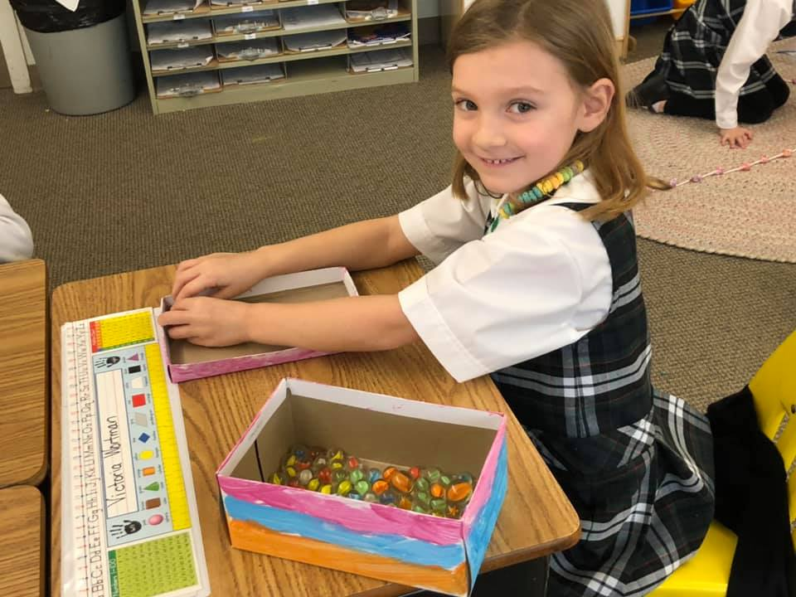

UPCOMING EVENTS:
Our Upcoming Week…

Tuesday Mary Poppins Practice
Wednesday Ash Wednesday

Looking Ahead…

March Reading Month!

March 20 End of 3rd Quarter
March 20-21 Mary Poppins Play

Save the dates!

Next Week’s Homework:
Monday- Holiday Delivery
Tuesday- Party Plans
Wednesday-Ready for Delivery
Thursday- Practice Spelling Test
Friday- No Homework

(Enjoy the Weekend!)

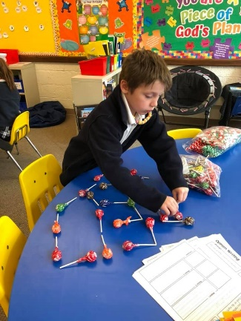

Here’s What We’re Doing Next Week!

Language Arts: visualizing, see/saw verbs, long i (i, igh, y)

Math: money

Religion: Lent

Writing: opinion writing

Science: the system & STEM challenge

Social Studies: dental health, American symbols

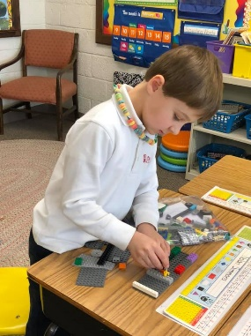
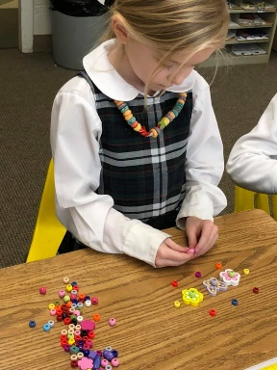

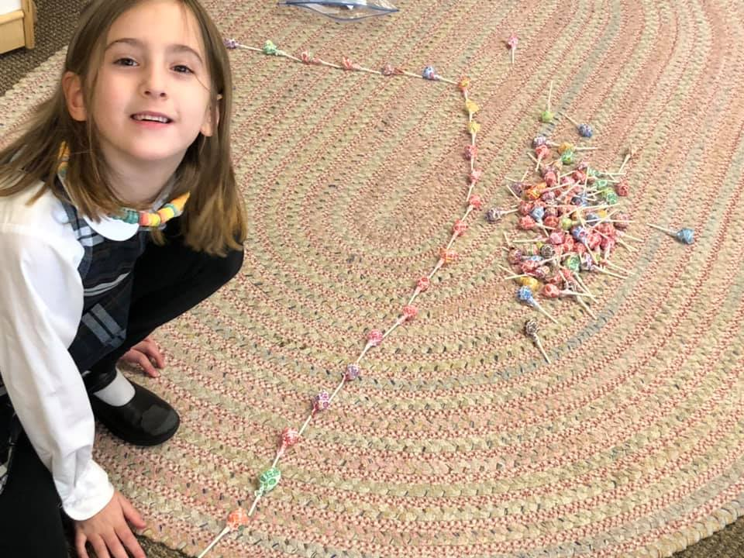

Weekly Specials:
Monday-Gym
Tuesday-Art
Wednesday-Music
Thursday-Library & Technology
Friday-Spanish
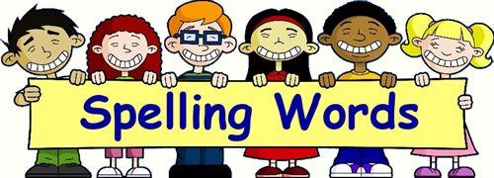
Next Week’s
Spelling/Sight Words
find
night
by
kind
right
my
ball
head
never
should
shout

Next Week’s Vocab Words:
approach
assist
determined
quarrel
view

