February 28, 2020

Well, this certainly was a short week of school! After a long winter break, I feel like we barely spent time together! The time we did have, though, was time well spent.

This Week in First Grade…

Language Arts- This week we focused on visualizing. We also worked on different ways of spelling the long i sound (y, igh, I, ie). In grammar we worked with the verbs see and saw.

Math- We began our new unit on counting money. This is proving to be challenging for some of them. Please practice counting money at home with them whenever the opportunity presents itself. Many students have trouble remembering what each coin is worth. So far we have learned the value of pennies, nickels, dimes, and quarters.

UPCOMING EVENTS:
Our Upcoming Week…

Monday Surprise reader: Patti Perliln (830)
Wednesday Surprise reader: Grayson’s Gma 240)
Thursday Surprise reader: Bridgette’s Gma (240)
Spero Golf

Looking Ahead…

March Reading Month! (please sign up to
be a surprise reader in our class!)

March 20 End of 3rd Quarter
March 20-21 Mary Poppins Play

Save the dates!

Next Week’s Homework:
Monday- Lead Me Home
Tuesday- Up, Up and Away
Wednesday-Walking the Dogs
Thursday- Practice Spelling Test
Friday- No Homework

(Enjoy the Weekend!)

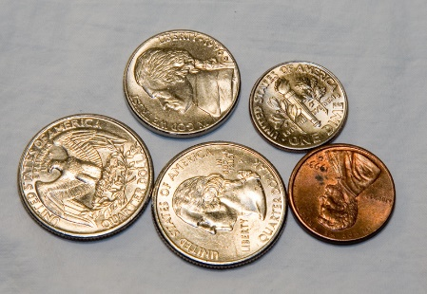

Here’s What We’re Doing Next Week!

Language Arts: visualizing, see/saw adverbs that tell when, long e (ey, y)

Math: money and time (hour, half hour)

Religion: we serve others

Writing: opinion writing

Science: muscles and joints

Social Studies: economics/goods and services

NEXT WEEK’S SPELLING
I was unable to print next week’s spelling list. Please use the words to the right to practice spelling with your children.

Weekly Specials:
Monday-Gym
Tuesday-Art
Wednesday-Music
Thursday-Library & Technology
Friday-Spanish
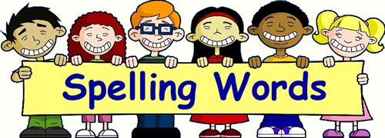
Next Week’s
Spelling/Sight Words
also
because
blue
bumpy
funny
or
other
penny
puppy
sandy
until

Next Week’s Vocab Words:
behavior
group
plead
soar
vivid

