February 7, 2020

It was another super week of learning in room 114!

This Week in First Grade…

Language Arts- This week we focused on the character and setting in our stories. We also worked on different ways of spelling the long e sound (e, ee, ea). In grammar we worked with the verbs has and have.

Math- We are still enjoying our work in geometry. This week we looked for faces and flat surfaces on 3D shapes. We also looked for 2D shapes within 3D shapes.

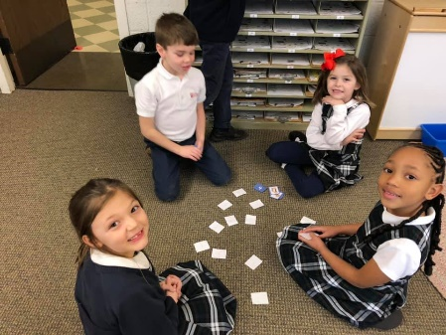
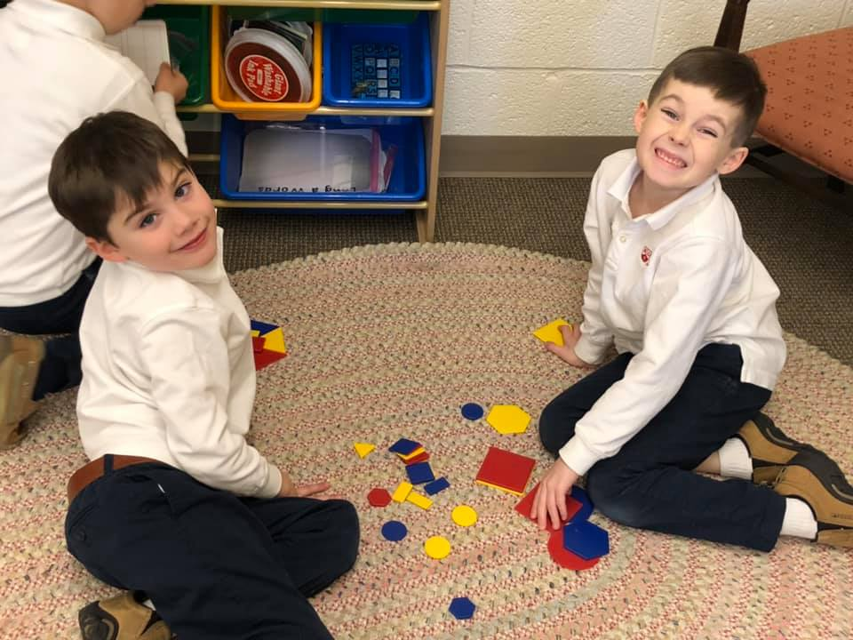

UPCOMING EVENTS:
Our Upcoming Week…

Tuesday Our Planned Mass 8:15 p.m.
100th Day of School

Looking Ahead…

Feb. 17-21 No School – Winter Break

March 20-21 Mary Poppins Play

Save the dates!

Next Week’s Homework:
Monday- Breakfast Drink
Tuesday- Nouns and Verbs
Wednesday-I Love My Pet
Thursday- Practice Spelling Test
Friday- No Homework

(Enjoy the Weekend!)

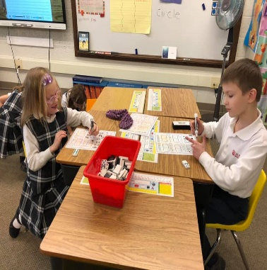

Here’s What We’re Doing Next Week!

Language Arts: retelling, go/do verbs, long o (o, oe, oa, ow)

Math: geometry

Religion: we are saints (God’s friends)

Writing: opinion writing

Science: unit assessment, the human body

Social Studies: president’s day, American symbols

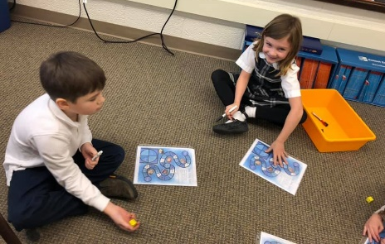
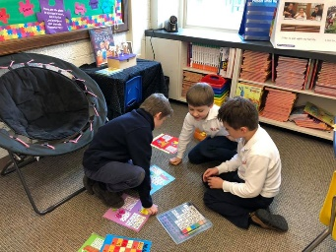
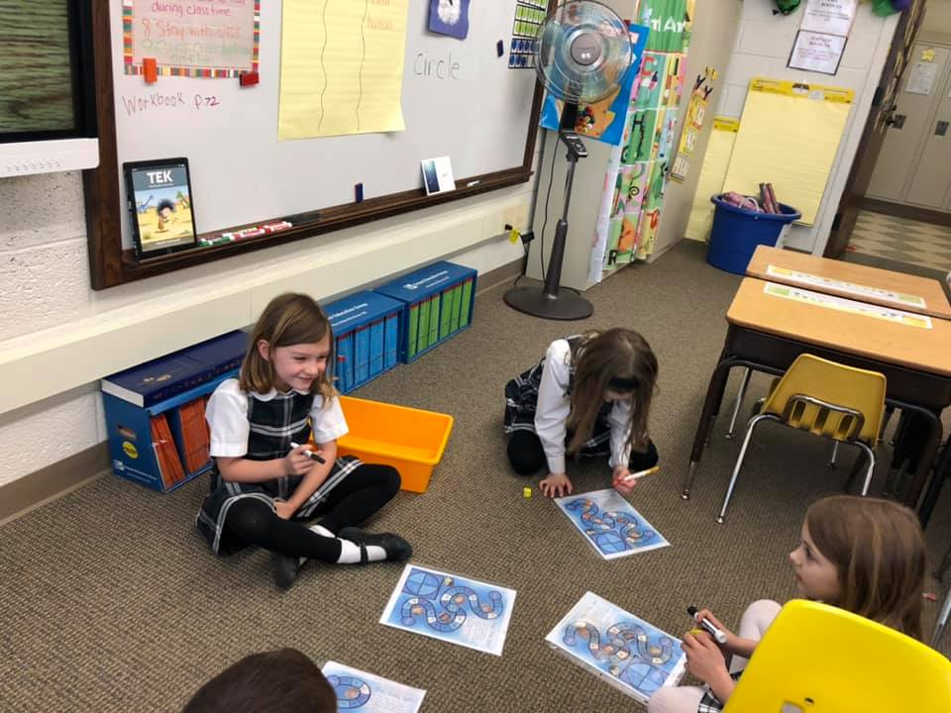
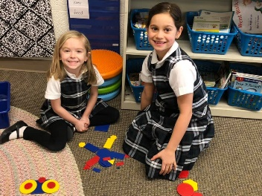

Weekly Specials:
Monday-Gym
Tuesday-Art
Wednesday-Music
Thursday-Library & Technology
Friday-Spanish
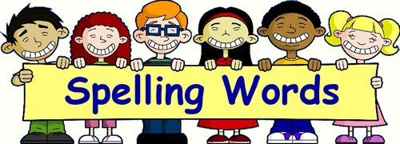
Next Week’s
Spelling/Sight Words
low
boat
no
row
coat
go
better
buy
change
move

Next Week’s Vocab Words:
accomplish
agree
argue
attempt
goal

